“And the peace of God, which surpasses all comprehension, will guard your hearts and your minds in Christ Jesus.” -- Philippians 4:7
- Please show all your work! No partial credit will be given for incorrect answers with no work shown. Please draw a box around your final answer.
- Calculators are permitted, but no notes, text, laptops, PDAs, or electronic dictionaries.
- Cell phones should be muted and left in your pocket or bag.
- You are asked not to use the matrix or special financial functions of your calculator.
Total marks: 110 + 5 extra credit

- Simplify: 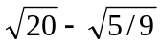 [2]
(5/3) sqrt(5)
- Simplify: 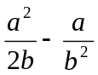 [2]
(a²b – 2a)/2b²
- Simplify: 16y²/(-2y^{1/2})³ [3]
-2sqrt(y)
- Calculate: log₇(149) [3]
log(149)/log(7) ≈ 2.173/0.845
≈ 2.5715
- Solve: w² – 9w + 20 = 0 [2]
w = -4, -5
- Solve: 2d² – 5d + 3 = 0 [3]
d = 1 or 3/2
- Solve: 3 ≤ | (z/2) – 4 | [3]
z ≤ 2 or z ≥ 14
- Consider the series 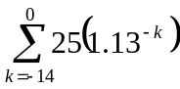.
  - What is the first term of the series? [1]
25(1.13¹⁴) ≈ 138.37
  - What is the last term of the series? [2]
25
  - What is the sum of the series? [3]
≈ 1010.44
- Consider the series 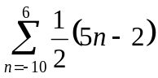.
  - What is the first term of the series? [1]
-26
  - What is the last term of the series? [2]
14
  - What is the sum of the series? [3]
-102
- Multiply: 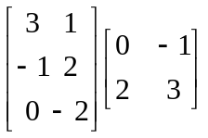 [3]
2 0
4 7
-4 -6
- Transpose the matrix from the previous problem. [2]
0 7 6
2 4 -4

- Let the functions f() and g() be given as 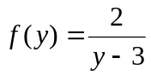 and 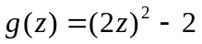.
  - Express 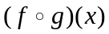 [2]
2 / ( (2x)² – 5 )
  - Express 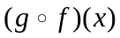 [2]
( 16 / (y-3)² ) - 2
  - Describe the domain and range of the function f(). [2]
Domain: y ≠ 3. Range: all real numbers
  - Describe the domain and range of the function g(). [2]
Domain: all real numbers. Range: g(z) ≥ -2
- Your $15,000 portfolio consists of mid-cap equities earning 14% and treasury bills earning 4.5% (both simple interest). After one year, your portfolio grows to a value of $16,549. How much is invested in equities and how much in T-bills? [4]
$9200 in equities; $5800 in T-bills
- Invert the matrix: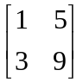 [4]
-3/2 5/6
½ -1/6
- A simple economy consists of (M)anufacturing and (T)ransportation. The input-output matrix is given below, in units of tens of billions of dollars. What production levels of M and T are required to meet an external demand of 10 units of M and 5 units of T? [6]
 | M | T | Final  demand
M | 10 | 12 | 8
T | 15 | 6 | 3
Other
A:
1/3 ½
½ 1/4
(I-A)⁻¹:
3 2
2 8/3
units Manufacturing
units Transportation
- Elma took out a mortgage for $310,000 to buy a house. She repaid this by fixed amounts at the end of each month for 25 years. The interest rate is 6.2% p.a. compounded monthly.
  - What are her monthly payments? [6]
≈ 310,000 * (0.062/12) / (1-(1+0.062/12)⁻³⁰⁰)
≈ $2035.40
  - What is the finance charge of the loan? [2]
≈ $300,621.35
- You have three debts that you wish to consolidate: $800 due 9 months ago, $700 due next month, and $1250 due 7 months from now. How much do you need to repay all three debts now? Assume interest is 18% per year, compounded monthly. [5]
800(1+.18/12)⁹ + 700(1+.18/12)⁻¹ + 1250(1+.18/12)⁻⁷
≈ 914.71 + 689.66 + 1126.28
≈ $2730.65
- An investment earns 15% a year, compounded continuously.
  - What is the effective annual rate (APY)? [2]
16.18%
  - How long will it take for an initial investment to double in value? [3]
≈ 4.62 yr
- You have a friend who charges $350 of expenses to his credit card each month (assume it is at the start of the month). He foolishly thinks a credit card means “free money”, so he makes no payments (yipes!). But the card has an 18.5% interest rate, compounded monthly.
  - After one year, how much will he owe on the credit card? Should you smack some sense into your friend? [4]
≈ 350 ( (1+.185/12)¹ – (1+.185/12)¹³ ) / (1- (1+.185/12))
≈ $4645.61
Smack!
  - (extra credit): To make matters worse, because of his non-payment, each year the bank raises the interest rate on this account by 5%. (These terms are taken from an actual RBC Visa Agreement.) After three years, besides the damage done to his credit rating, how much will he owe on the credit card? [5]
Just from 2nd year @23.5%: $4774.96
Just from 3rd year @28.5%: $4908.34
1st year bal after earning interest @23.5% and 28.5%: $7770.38
2nd year bal after more interest @28.5%: $6328.44
Total: $7770.38 + $6328.44 + $4908.34
≈ $19,007.16
Smack!
- A small business is trying to model its supply/demand curves. When the price is $12 per unit, the customers demand 480 units per week. When the price is $10 per unit, the demand increases to 800 units per week.
  - Find a linear model to give the price P (in $/unit) as a function of the quantity Q demanded (units/week). [3]
P = -Q/160 + 15
  - What is the business interpretation of the P-intercept (y-intercept) of the above linear equation? [2]
Customers won’t buy any units if the price is above $15/unit.
  - According to this linear model, how many units will customers demand when the price is $0? [2]
(15)(160) = 2400 units/week
  - Is a straight line a good model for real-world demand? Why or why not? [2]
Doesn’t make sense –
if price is $0 (free), then demand should be infinite
  - Find the level of production that will maximize revenue. [4]
R = PQ = (-1/160)Q² + 15Q
vertex@ Q = 1200 units/week
  - The business’ supplier might not be willing to meet such a large demand, though. If the supply equation is modeled as P = (1/250)Q + 4.75, find the equilibrium point. [3]
P = $8.75/unit, Q = 1000 units/week.
- From each ton of ore 1 a company can extract 100lb of mineral A and 200lb of mineral B. From each ton of ore 2 they can extract 200lb of mineral A and 50lb of mineral B. The company needs to produce at least 3000lb of A and 2500lb of B.
  - Sketch a graph, shading in the region representing the amount of each kind of ore the company can extract each day. [7]
.
100x + 200y ≥ 3000
200x + 50y ≥ 2500
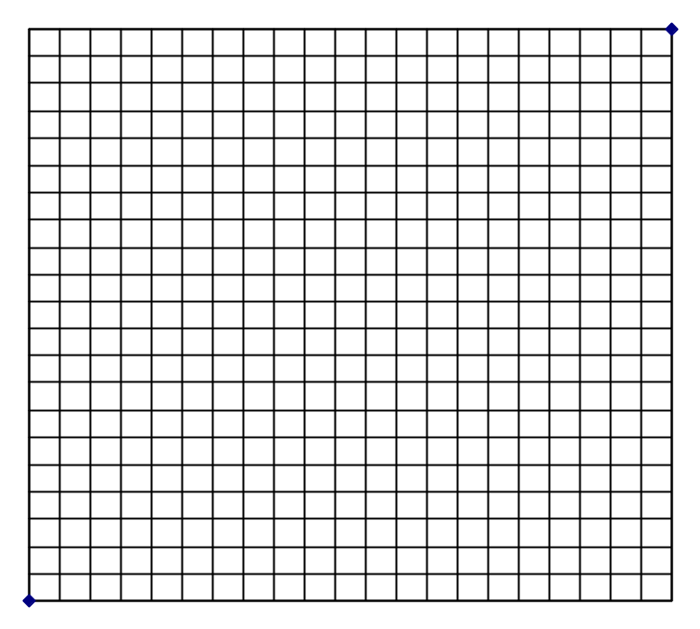
  - Each ton of ore 1 costs $50 to process, and each ton of ore 2 costs $60 to process. How many tons of each ore should the company process in order to minimize cost? What is that minimum cost? [3]
Ore 1: 10 tons, ore 2: 10 tons; cost: $1100

